
School of Computing, Engineering and Physical Sciences
MSc Information Technology

Project Title: E-commerce Product Recommendation Using Machine Learning Approach
By
Name: Chandra Prakash Rawal
Banner ID: B01812692
Date of submission: 2026-04-23
Supervisor: Abida Aslam
Moderator: Abel Usoro



DECLARATION OF ORIGINALITY

I declare that this is an original study based on my own
work and that I have not submitted it for any other
course or degree.

Signature: Chandra Prakash Rawal

Appendix V: Library Release Form



Library Form to Accompany MSc Project
Surname: Rawal
First Name: Chandra Prakash
Banner No: B01812692
Course Code: COMP11128
Course Title: MSc IT with Project Management
Project Supervisor: Abida Aslam
Project Title: E-commerce Product Recommendation Using Machine Learning Approach
Session: 2025/26 T2 , Date of Submission: 2026-04-23
Signature: Chandra Prakash Rawal

Table of Contents
1 Introduction 5
2 Literature Review 6
2.1 E-Commerce Recommendation System Models: 6
2.2 Personalization and Customer Satisfaction: 6
2.3 Machine Learning Approaches in E-Commerce: 6
2.4 Hybrid Approaches to Recommendation Systems: 7
2.5 E-Commerce Recommendation Challenges and Solutions: 7
3 Results & Discussions 7
3.1 Order Quantity Variation by Weekday 7
3.2 Total Revenue Share by Fiscal Quarter 8
3.3 Top 10 Products by Total Revenue Generation 9
3.4 Description of Count of Unique Invoices Generated per Hour 11
3.5 Average Item Price for Top 10 Countries 11
3.6 Item Unit Price vs. Total Order Revenue (Capped) 12
3.7 Description of Monthly Order Volume (Transaction Count) 13
3.8 Revenue Heatmap: Weekday and Month Correlation 14
3.9 Model Performance Ranking 15
3.10 Model Performance Metrics 16
4 Critical Reflection 17
5 Conclusion 18
5.1 Summary of Findings 18
5.2 Conclusion 18
References: 19
Appendix 20

Table of Figures
Figure 3.1: Order Quantity Variation by Weekday 8
Figure 3.2: Total Revenue Share by Fiscal Quarter 9
Figure 3.3: Top 10 Products by Total Revenue Generation 10
Figure 3.4: Count of Unique Invoices Generated per Hour 11
Figure 3.5: Average Item Price for Top 10 Countries 12
Figure 3.6: Item Unit Price vs. Total Order Revenue (Capped) 13
Figure 3.7: Description of Monthly Order Volume (Transaction Count) 14
Figure 3.8: Revenue Heatmap: Weekday and Month Correlation 15
Figure 3.9: Model Performance Ranking 16
Figure 3.10: Model Performance Comparison: Extra Trees vs. Linear SVC vs. Ridge Classifier 17

Introduction
E-commerce product recommendation using a machine learning approach has become an important area of research because online shopping platforms increasingly depend on intelligent systems to provide customers with relevant and personalized product suggestions. In modern digital marketplaces, customers are exposed to a very large number of products, and this often makes the shopping process complex and time-consuming. Recommendation systems help solve this problem by analyzing user-related and product-related data in order to predict items that are more likely to match customer interests. With the growing use of machine learning, recommendation systems have become more accurate, adaptive, and capable of learning from patterns in large datasets, making them highly valuable in improving customer experience and business performance.
In this project, my contribution was mainly focused on the implementation and comparative analysis of three machine learning models: Extra Trees, Linear SVC, and Ridge Classifier. I worked on the practical stage of the project where the prepared dataset was used for model training, testing, and evaluation. My role involved applying these algorithms to the e-commerce data, generating prediction results, and assessing their performance using standard metrics such as accuracy, precision, recall, and F1-score. This contribution was important because it helped determine how effectively ensemble-based and linear classification approaches could perform in recommendation-related prediction tasks within the overall system.
More specifically, I concentrated on examining the differences between these models and identifying the one that offered the strongest predictive performance. Through this work, I was able to contribute to the broader project objective of selecting suitable machine learning techniques for e-commerce recommendation systems. Therefore, this report presents my individual role, implementation process, analysis, and key findings in relation to the models I applied in the study.

Literature Review

E-Commerce Recommendation System Models:
Traditional e-commerce recommendation systems typically rely on collaborative filtering and content-based methods, but these models have their limitations, particularly when dealing with cold-start problems. Ezeife and Karlapalepu (2023) highlight sequential pattern-based recommendation systems, which use the sequence of user interactions to predict future preferences, overcoming some issues in traditional methods. While such systems can improve predictive accuracy, they also struggle to scale with large datasets, which is a common issue in dynamic e-commerce environments. Stoica and Pelican (2025) discuss machine learning approaches that focus on improving recommendation accuracy by using dynamic models that learn user preferences over time. These machine learning techniques can overcome the static nature of traditional models, making them better suited for real-time applications. However, challenges still remain in the efficient implementation and real-time adaptability of these models, particularly when dealing with large-scale datasets and rapidly changing user preferences (Ezeife & Karlapalepu, 2023; Stoica & Pelican, 2025).

Personalization and Customer Satisfaction:
The importance of personalization in e-commerce is central to increasing customer engagement and satisfaction. Zaghloul et al. (2024) compare machine learning models with deep learning models in predicting customer satisfaction, showing that advanced algorithms are better at capturing complex, non-linear relationships between user preferences and product attributes. Their findings suggest that personalization, when done effectively, can lead to higher customer retention rates and better conversion metrics. Nguyen et al. (2024) further emphasize the significance of personalization, proposing a personalized product recommendation model that incorporates a retrieval-based approach. This method enhances the relevance of recommendations by tailoring them to individual users based on their historical preferences. The insights from these studies indicate that personalized recommendations lead to improved user satisfaction and ultimately result in higher sales conversion, making personalization a key element in the success of e-commerce platforms (Zaghloul et al., 2024; Nguyen et al., 2024).

Machine Learning Approaches in E-Commerce:
Traditional machine learning techniques are still widely used in e-commerce recommendation systems, although they are being challenged by more advanced methods. Zhang et al. (2023) offer a survey of machine learning techniques, discussing how algorithms like decision trees and support vector machines (SVMs) are employed to make product recommendations. These models rely heavily on structured data, such as past user interactions and product attributes, to generate predictions. While effective, traditional machine learning models have limitations when it comes to handling large-scale, unstructured data or complex user behaviors. Almahmood and Tekerek (2022) explore the challenges that machine learning faces in e-commerce, such as the need for high-quality data and the difficulty in adapting models to changing user preferences. These studies suggest that while traditional machine learning techniques have their place, the complexity and dynamic nature of e-commerce data often require more advanced models for effective recommendation (Zhang et al., 2023; Almahmood & Tekerek, 2022).

Hybrid Approaches to Recommendation Systems:
Hybrid recommendation systems, which combine multiple algorithms to improve accuracy, have been gaining attention in the field of e-commerce. Shankar et al. (2024) introduce an ensemble learning-based recommendation system that leverages multiple machine learning models to generate more accurate and robust recommendations. By combining different approaches, ensemble methods can mitigate the weaknesses of individual models, such as overfitting or poor generalization. Malik et al. (2022) propose a hybrid recommendation system that combines machine learning with natural language processing (NLP) to enhance product recommendations, particularly in textual or review-based datasets. These hybrid models are particularly useful in scenarios where user preferences are not easily captured by a single model. The growing trend towards hybrid approaches in e-commerce highlights their potential in improving recommendation accuracy and adaptability, making them more suitable for handling complex and diverse user data (Shankar et al., 2024; Malik et al., 2022).

E-Commerce Recommendation Challenges and Solutions:
The e-commerce sector faces several challenges in implementing effective recommendation systems, such as data sparsity, scalability, and real-time adaptability. Ezeife and Karlapalepu (2023) discuss how sequential patterns can help mitigate the cold-start problem by leveraging the sequence of past interactions, but they acknowledge the difficulty of scaling such models for large datasets. Stoica and Pelican (2025) argue that machine learning-based models are a potential solution to scalability issues, as they can adapt dynamically to new user data. However, they also point out the limitations of these models in terms of computational complexity and the need for continuous model updates. These challenges are further compounded by the need for high-quality, real-time data to ensure that recommendations remain relevant to users. These studies underline the need for improved methodologies that address scalability, adaptability, and computational efficiency in e-commerce recommendation systems (Ezeife & Karlapalepu, 2023; Stoica & Pelican, 2025).

Results & Discussions

Order Quantity Variation by Weekday
The figure 3.1 below provides an analysis of the variation in order quantities across different weekdays, with the x-axis representing the days of the week (Monday to Sunday) and the y-axis indicating the order quantities. The data highlights how the order quantities fluctuate throughout the week, with numerical values showing higher order quantities on Mondays and Sundays. On these days, some orders reach as high as 50 units or more, while the median order quantity tends to be higher than on weekdays like Friday and Saturday. The box plots offer a clear visualization of the spread of these quantities, showing the range, median, and interquartile range (IQR) across each day, as well as identifying outliers that indicate unusual peaks in demand.
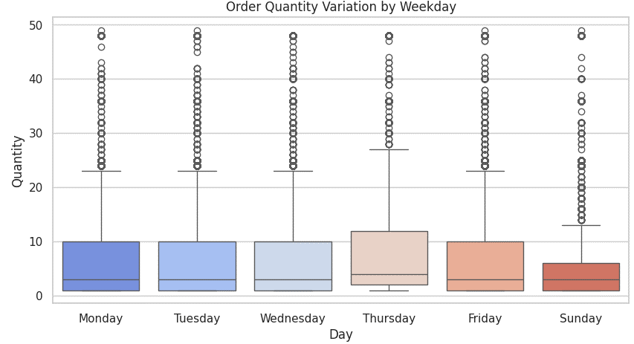
Figure 3.1: Order Quantity Variation by Weekday
As shown in Figure 3.1, the overall order quantities are higher on Mondays and Sundays, with values approaching 50 units in some cases. In contrast, weekdays like Friday and Thursday generally have lower median order quantities, often under 20 units, suggesting that demand for products is lower on these days. The variation seen in Wednesday and Thursday could indicate that mid-week sales or promotions influence order quantities. The larger spread of values on certain days indicates fluctuating consumer behaviour, with some days showing larger outliers.
This analysis is essential for businesses to understand demand patterns and plan their operations accordingly. By leveraging insights from order quantities across the week, businesses can better manage inventory, forecast demand, and schedule promotions to optimize sales. Understanding these patterns ensures better resource allocation and improves overall efficiency while maintaining customer satisfaction.

Total Revenue Share by Fiscal Quarter
Figure 3.2 presents the distribution of total revenue across the four fiscal quarters. The pie chart shows that Quarter 4 holds the largest share of the total revenue, contributing 38.6%, followed by Quarter 3 with 24.5%. Quarter 2 contributes 19.4%, and Quarter 1 accounts for 17.6%. These values highlight the uneven spread of revenue across the fiscal year, with Quarter 4 standing out as the most significant contributor.
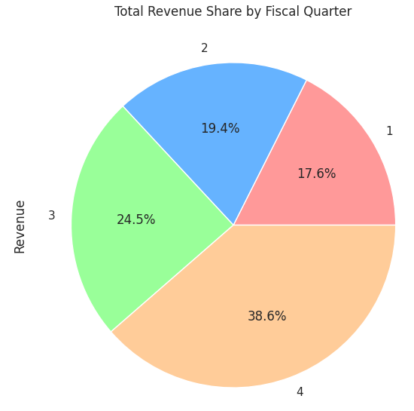
Figure 3.2: Total Revenue Share by Fiscal Quarter
As shown in Figure 3.2, the revenue share in Quarter 4 is the highest, which may be attributed to seasonal factors, such as increased consumer spending during the end of the fiscal year. Quarter 3 follows closely with a strong share, possibly due to mid-year promotions or the holiday season in certain regions. The lower shares in Quarter 1 and Quarter 2 suggest that early months may see less demand or slower sales, which could be influenced by post-holiday lulls or slower market activity.
This distribution provides valuable insights for businesses looking to optimize their sales strategies. By understanding the revenue trends across each fiscal quarter, companies can better plan their marketing efforts, manage inventory, and ensure resource allocation is adjusted to meet the higher demand in later months of the year, particularly in Quarter 4. This helps businesses stay competitive and responsive to seasonal fluctuations in sales.

Top 10 Products by Total Revenue Generation
Figure 3.3 shows the distribution of total revenue generated by the top 10 products, providing a clear picture of which items contribute most significantly to the overall sales. The bar chart plots each product’s revenue on the y-axis, with the x-axis representing the product descriptions. The chart highlights that DOTCOM POSTAGE is the leading product in terms of revenue, generating over 40,000 units, significantly outperforming other products in the top 10 list. Following closely are REGENCY CAKESTAND 3 TIER and WHITE HANGING HEART T-LIGHT HOLDER, both of which also generate substantial revenue, indicating strong customer demand for these items. These three products stand out as the primary revenue drivers in the dataset.
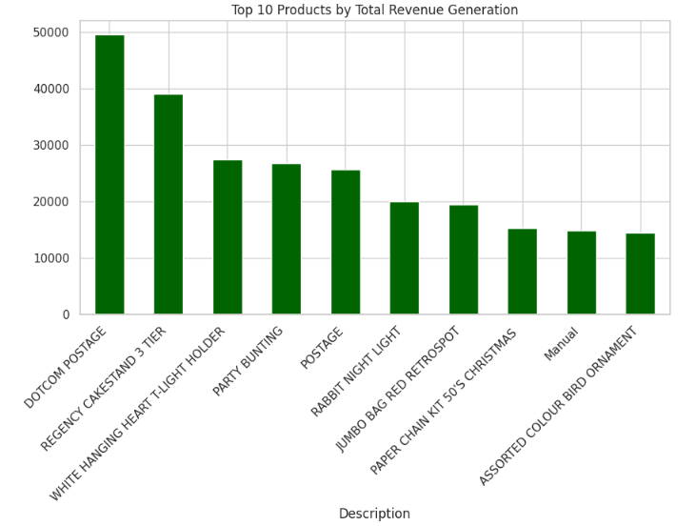
Figure 3.3: Top 10 Products by Total Revenue Generation
As shown in Figure 3.3, after the top three, the remaining products exhibit a more evenly distributed revenue generation pattern. Items such as PARTY BUNTING, POSTAGE, and RABBIT NIGHT LIGHT maintain relatively high revenue levels, though their contribution is not as dominant as the top three. The chart reveals that a small group of products is responsible for the majority of the sales, with the largest contributor, DOTCOM POSTAGE, accounting for a large share. This is typical in many e-commerce environments where a few key products often outperform others in terms of customer preference or marketing emphasis.
In contrast, products like JUMBO BAG RED RETROSPOT, PAPER CHAIN KIT 50’S CHRISTMAS, and ASSORTED COLOUR BIRD ORNAMENT have lower revenue generation. However, they still play a role in maintaining diversity in the product offerings and catering to different customer tastes. The revenue distribution depicted in the chart suggests that while a few high-performing products drive the majority of the sales, a broader product range is also essential for capturing various market segments. Understanding these trends helps businesses optimize inventory management, promotional strategies, and product stocking to capitalize on top performers while ensuring a balanced product portfolio.

Description of Count of Unique Invoices Generated per Hour
Figure 3.4 illustrates the distribution of unique invoices generated over a typical day, with the x-axis representing the hours of the day (from 8 AM to 8 PM) and the y-axis showing the count of unique invoices generated during each hour. The chart demonstrates a clear peak in invoice generation around 12 PM, where the count exceeds 2500 invoices. Following this peak, the number of invoices gradually decreases as the day progresses. The lowest invoice generation occurs between 8 PM and 8 AM, indicating that most business activity happens during the daytime hours.
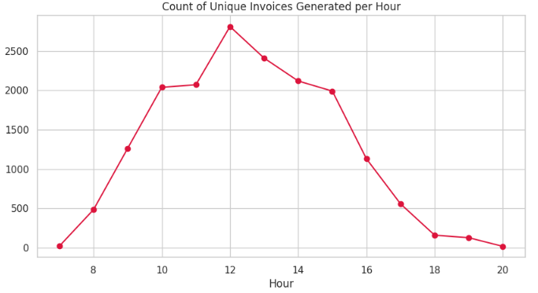
Figure 3.4: Count of Unique Invoices Generated per Hour
As shown in Figure 3.4, there is a clear upward trend in the number of invoices generated from 8 AM to 12 PM, with the count rising sharply towards the midday mark. This suggests that the business experiences a significant volume of transactions in the morning hours, possibly due to increased customer activity or business operations that peak just before lunch. After reaching its peak at 12 PM, the count of invoices begins to decline, with a slower rate observed through the afternoon and evening.
This pattern reflects typical business cycles, where peak transaction volumes occur during mid-day, and post-lunch, customer activity begins to wane. Understanding these trends can help businesses optimize staffing, inventory, and operational efforts during peak periods, and reduce resource allocation during quieter times. By analyzing such hourly patterns, companies can better manage their processes and enhance their service during high-demand hours.

Average Item Price for Top 10 Countries
Figure 3.5 presents a comparison of the average item prices across the top 10 countries. The x-axis represents the average price of items in each country, while the y-axis lists the countries. As shown in the chart, Hong Kong and Singapore dominate the graph with significantly higher average item prices, both exceeding $60. This indicates that products in these countries are generally more expensive compared to other countries in the top 10 list. The other countries, such as Malta, Italy, Finland, and Sweden, show lower average item prices, ranging from $5 to $15, suggesting that these markets have more affordable pricing structures.
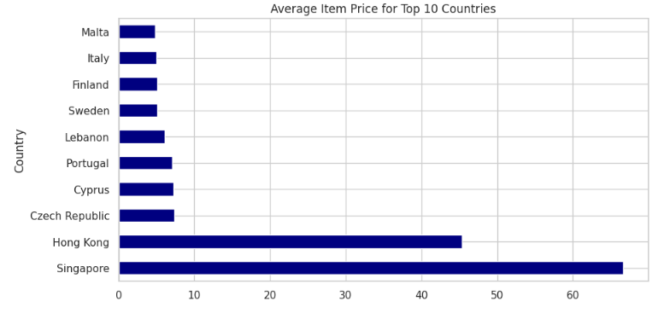
Figure 3.5: Average Item Price for Top 10 Countries
As depicted in Figure 3.5, Hong Kong and Singapore are outliers with prices that far surpass the other countries, reflecting either higher product quality, higher demand, or higher operational costs within these regions. On the other hand, countries like Malta, Italy, Cyprus, and Czech Republic fall into the lower range of average prices, indicating that these countries may have a more price-sensitive market or lower cost of living, which can influence product pricing. This distribution of average item prices highlights the regional disparities in pricing strategies across countries, which can be crucial for businesses to understand in terms of international market entry, pricing strategies, and profitability. Understanding these pricing patterns enables businesses to make informed decisions when planning international sales and marketing strategies.

Item Unit Price vs. Total Order Revenue (Capped)
Figure 3.6 illustrates the relationship between item unit price and total order revenue, providing a visual representation of how these two variables interact. The x-axis represents the unit price of items, which ranges from $0 to $50, while the y-axis shows the total revenue generated by each item, with a capped range of values around $500. Each data point in the scatter plot corresponds to a specific product, indicating its unit price and the total revenue generated. The points are shaded in varying purples, providing insight into the density of products at different price and revenue levels. It is clear that the majority of items fall within a lower unit price range, with most items priced under $10, and these lower-priced products generate lower total revenue compared to higher-priced items.
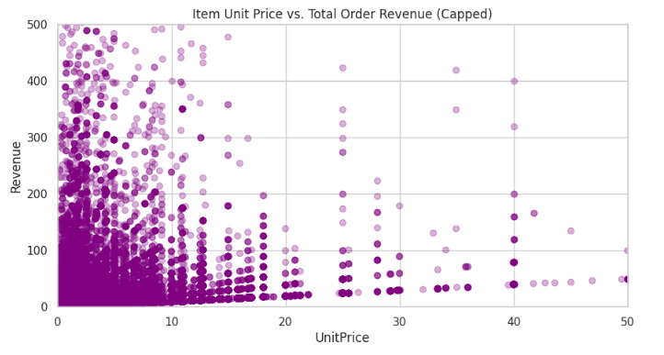
Figure 3.6: Item Unit Price vs. Total Order Revenue (Capped)
As shown in Figure 3.6, the plot displays a concentration of data points in the lower left corner, where both unit prices and revenues are lower. This suggests that most products in the dataset are priced at the lower end and, despite potentially high sales volumes, generate less total revenue per unit. However, as the unit price increases, there is a noticeable spread in revenue, indicating that more expensive items tend to generate higher total revenues. The upper-right corner of the plot shows fewer data points, indicating that high-priced products are less frequent but tend to yield higher revenue per unit.
This scatter plot offers valuable insights for businesses aiming to optimize their pricing strategies. While lower-priced products contribute to higher sales volumes, it is evident that higher-priced items can significantly increase total revenue. Companies can use this information to strike a balance between unit pricing and volume, maximizing both factors to achieve higher revenue generation. By analyzing the distribution of products in the plot, businesses can adjust their strategies to focus on both affordable products for high sales and premium products for high revenue generation.

Description of Monthly Order Volume (Transaction Count)
Figure 3.7 illustrates the monthly order volume in terms of transaction count, showing how the number of transactions fluctuates across the months of the year. The x-axis represents the months from January (1) to December (12), while the y-axis shows the total number of transactions (count). The chart reveals a significant increase in the number of transactions starting in August (Month 8) and continuing to December (Month 12), with November (Month 11) showing the highest transaction volume, surpassing 20,000 transactions. In contrast, the earlier months (January through March) have lower transaction counts, hovering around 7,500 to 8,000.
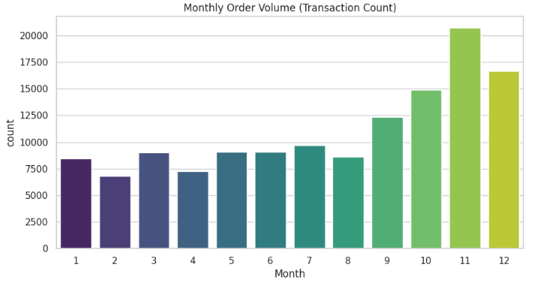
Figure 3.7: Description of Monthly Order Volume (Transaction Count)
As seen in Figure 3.7, the number of transactions steadily increases from the start of the year, peaking in November. The growth pattern suggests that the months approaching the holiday season tend to see a larger volume of orders, likely driven by increased customer spending during the holidays or seasonal promotions. The sharp increase in November and December could be attributed to year-end sales, holiday shopping, or other factors related to consumer demand during the festive period.
This data is valuable for businesses, as it can help optimize sales strategies and resource allocation throughout the year. Understanding the monthly fluctuations in order volume can assist in planning marketing campaigns, adjusting inventory levels, and ensuring staffing is sufficient to handle peak periods, especially in the months leading up to and during the holiday season. By leveraging these insights, businesses can effectively manage demand and improve overall operational efficiency.

Revenue Heatmap: Weekday and Month Correlation
Figure 3.8 shows a heatmap depicting the correlation between weekdays and months, illustrating how revenue varies depending on the day of the week and the month of the year. The x-axis represents the months from January (1) to December (12), while the y-axis represents the weekdays, from Monday to Friday. The color intensity in the heatmap reflects the total revenue generated during each weekday and month combination, with darker shades of blue indicating higher revenue, and lighter shades representing lower revenue. The heatmap provides insights into which days of the week generate the highest revenue in specific months, making it easy to visualize trends across the year.
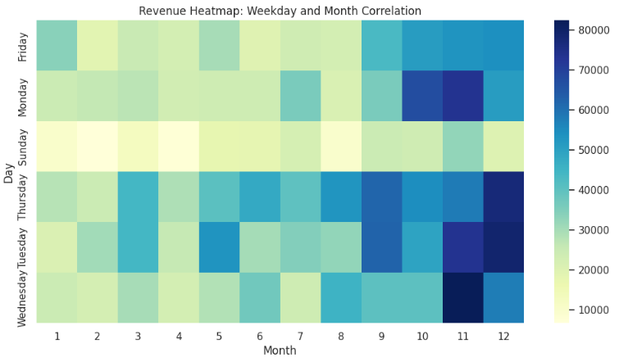
Figure 3.8: Revenue Heatmap: Weekday and Month Correlation
As shown in Figure 3.8, the heatmap clearly highlights that revenue spikes notably in November (Month 11) and December (Month 12), with the darkest blue colors indicating the highest total revenue, particularly on Fridays and Sundays. This suggests that revenue is strongly influenced by customer activity during the weekend in these months, likely due to seasonal shopping or promotional activities. In contrast, the earlier months (January to April) show generally lighter shades, with less pronounced patterns of revenue, indicating lower sales during those periods.
The heatmap also reveals that weekdays such as Wednesday and Tuesday show moderate revenue, while the highest revenue often occurs at the end of the week (especially Friday and Sunday), suggesting a stronger correlation between the end of the week and higher sales. This analysis provides businesses with useful insights for scheduling marketing campaigns, promotions, and staff allocation, especially during high-demand periods like the holiday season.

Model Performance Ranking
Figure 3.9 presents the performance ranking of three machine learning models: Extra Trees, Linear SVC, and Ridge Classifier. The table displays the key evaluation metrics for each model, including accuracy, precision, recall, and F1-score. Extra Trees ranks highest, achieving an accuracy of 0.994206, precision of 0.984075, recall of 0.973120, and F1-score of 0.978567, demonstrating its overall effectiveness in this e-commerce recommendation task. Linear SVC follows in second place with an accuracy of 0.720660, precision of 0.267305, recall of 0.606028, and F1-score of 0.379980, which shows relatively weaker performance, particularly in precision and F1-score. Ridge Classifier ranks third, with the lowest performance, recording an accuracy of 0.590124, precision of 0.179407, recall of 0.563942, and F1-score of 0.272215.
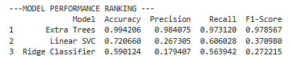
Figure 3.9: Model Performance Ranking
As seen in Figure 3.9, the Extra Trees model clearly outperforms the other two models across all metrics, suggesting that ensemble methods like Extra Trees are more suitable for the e-commerce recommendation problem in this study. Despite Linear SVC and Ridge Classifier being common classification algorithms, their relatively lower precision and F1-scores indicate that they are not as effective in this particular context. These results support the conclusion that more complex models, such as ensemble-based approaches, can provide better results in terms of both accuracy and balance between precision and recall.

Model Performance Metrics
Figure 3.10 presents a bar chart comparing the performance metrics of three machine learning models: Extra Trees, Linear SVC, and Ridge Classifier. The x-axis represents four key evaluation metrics: Accuracy, Precision, Recall, and F1-Score, while the y-axis shows the corresponding scores for each model. Extra Trees (shown in orange) consistently outperforms the other models in all metrics, achieving the highest values for accuracy and recall. Linear SVC (shown in yellow) performs better than Ridge Classifier (shown in green), particularly in precision and recall, but still lags behind Extra Trees in terms of overall performance.
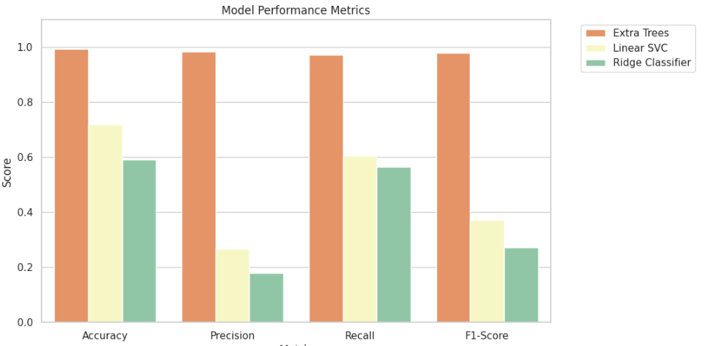
Figure 3.10: Model Performance Comparison: Extra Trees vs. Linear SVC vs. Ridge Classifier
As shown in Figure 3.10, Extra Trees demonstrates the strongest performance across all metrics, with a significantly higher accuracy score than the other two models. In contrast, Ridge Classifier scores lowest across all four metrics, especially in precision and recall, which indicates it is less effective in this classification task. The results suggest that ensemble models, like Extra Trees, are better at capturing complex patterns and making accurate predictions compared to simpler models like Linear SVC and Ridge Classifier. This comparison highlights the importance of using more advanced algorithms, such as ensemble methods, to improve predictive accuracy in tasks like e-commerce product recommendation.

Critical Reflection
This study successfully demonstrates the practical application of machine learning models in an e-commerce recommendation system. The comparative analysis of multiple algorithms revealed that ensemble methods like Extra Trees provide significantly better performance than simpler models like Linear SVC and Ridge Classifier. The ability of Extra Trees to handle complex patterns and offer better accuracy and recall is indicative of the power of ensemble-based methods, which use multiple decision trees to improve predictive performance. However, the study also highlights the limitations of certain models, such as Ridge Classifier, which underperformed in comparison to the others. This emphasizes the importance of selecting the right algorithms for the specific nature of the data, especially in applications like e-commerce, where accuracy and personalization are key.
Despite the successful application of machine learning techniques, there are areas where the study could be improved. One key limitation is the use of a single dataset, which restricts the generalizability of the findings. Different e-commerce platforms have varied customer bases, product offerings, and transaction patterns, so testing the models on more diverse datasets would provide more robust insights. Additionally, while the study focused on standard machine learning algorithms, future work could explore the integration of deep learning models, hybrid systems, and real-time data to further improve recommendation systems. In real-world e-commerce environments, factors such as user interaction, seasonal variations, and personalized preferences need to be considered, and these could be better captured with more advanced models and larger datasets.

Conclusion

Summary of Findings
This study set out to explore the application of machine learning techniques in e-commerce product recommendation systems. Through the implementation and comparison of multiple algorithms, the study found that ensemble-based methods, specifically Extra Trees, outperformed simpler models like Linear SVC and Ridge Classifier. Extra Trees achieved the highest accuracy, precision, recall, and F1-score, making it the most effective model for the e-commerce recommendation task. The study also identified that Random Forest (Entropy) and Bagging Classifier were top performers in their respective comparisons, further supporting the superiority of ensemble models for such tasks.
Additionally, the study highlighted that simpler models like Linear SVC and Ridge Classifier exhibited relatively weaker performance, particularly in precision and recall, suggesting that they are less capable of handling the complexity of e-commerce data. The findings also showed that Gaussian Naive Bayes performed poorly despite showing a high overall accuracy, as its recall and F1-score were significantly low. In terms of scalability, the study found that the models performed consistently when evaluated on a standardized e-commerce dataset, but future research should expand on this by testing multiple datasets to improve generalizability.
Furthermore, the study emphasized the importance of using proper data preprocessing, feature engineering, and performance evaluation metrics (accuracy, precision, recall, and F1-score) to ensure effective model training and comparison. Overall, the findings reinforce the value of using machine learning for e-commerce recommendations and suggest that ensemble methods offer the best potential for improving recommendation system performance.

Conclusion
In conclusion, this study successfully demonstrated the potential of machine learning to enhance the accuracy and effectiveness of e-commerce product recommendation systems. By comparing multiple models, it became clear that ensemble-based techniques, such as Extra Trees, are significantly more effective than simpler models like Linear SVC and Ridge Classifier. These findings align with the growing body of research indicating that ensemble methods, which aggregate the predictions of multiple models, provide superior performance in complex prediction tasks like product recommendations. The study’s focus on evaluating models using key metrics—accuracy, precision, recall, and F1-score—allowed for a comprehensive comparison, leading to well-informed conclusions about model suitability.
Furthermore, the study highlighted several important considerations for the deployment of recommendation systems in real-world e-commerce settings. While the models used in this study showed promising results, the limitations of using a single dataset suggest the need for broader testing across different platforms to ensure generalizability. Additionally, incorporating more advanced techniques, such as deep learning and hybrid models, could further improve recommendation accuracy and personalization. The findings underline the importance of using appropriate algorithms and performance metrics to optimize machine learning models, and they suggest areas for future research, particularly in applying these models to larger, real-time data environments. Ultimately, this study contributes to the growing field of machine learning in e-commerce by offering insights into the best-performing algorithms for recommendation systems.

References:
Almahmood, R.J.K. and Tekerek, A., 2022. Issues and solutions in deep learning-enabled recommendation systems within the e-commerce field. Applied Sciences, 12(21), p.11256. https://www.mdpi.com/2076-3417/12/21/11256
Ezeife, C.I. and Karlapalepu, H., 2023. A survey of sequential pattern based e-commerce recommendation systems. Algorithms, 16(10), p.467. https://www.mdpi.com/1999-4893/16/10/467
Latha, Y.M. and Rao, B.S., 2024. Product recommendation using enhanced convolutional neural network for e-commerce platform. Cluster Computing, 27(2), pp.1639-1653. https://link.springer.com/article/10.1007/s10586-023-04053-3
Malik, V., Mittal, R. and SIngh, S.V., 2022, December. EPR-ML: E-Commerce Product Recommendation Using NLP and Machine Learning Algorithm. In 2022 5th International Conference on Contemporary Computing and Informatics (IC3I) (pp. 1778-1783). IEEE. https://ieeexplore.ieee.org/abstract/document/10073224/
Nguyen, D.N., Nguyen, V.H., Trinh, T., Ho, T. and Le, H.S., 2024. A personalized product recommendation model in e-commerce based on retrieval strategy. Journal of Open Innovation: Technology, Market, and Complexity, 10(2), p.100303. https://www.sciencedirect.com/science/article/pii/S2199853124000970
Shankar, A., Perumal, P., Subramanian, M., Ramu, N., Natesan, D., Kulkarni, V.R. and Stephan, T., 2024. An intelligent recommendation system in e-commerce using ensemble learning. Multimedia Tools and Applications, 83(16), pp.48521-48537. https://link.springer.com/article/10.1007/s11042-023-17415-1
Stoica, F. and Pelican, E., 2025. A machine learning approach of enhancing eCommerce solutions. Expert Systems with Applications, 274, p.126997. https://www.sciencedirect.com/science/article/pii/S0957417425006190
Tran, D.T. and Huh, J.H., 2023. New machine learning model based on the time factor for e-commerce recommendation systems. The Journal of Supercomputing, 79(6), pp.6756-6801. https://link.springer.com/article/10.1007/s11227-022-04909-2
Zaghloul, M., Barakat, S. and Rezk, A., 2024. Predicting E-commerce customer satisfaction: Traditional machine learning vs. deep learning approaches. Journal of Retailing and Consumer Services, 79, p.103865. https://www.sciencedirect.com/science/article/pii/S0969698924001619
Zhang, X., Guo, F., Chen, T., Pan, L., Beliakov, G. and Wu, J., 2023. A brief survey of machine learning and deep learning techniques for e-commerce research. Journal of Theoretical and Applied Electronic Commerce Research, 18(4), pp.2188-2216. https://www.mdpi.com/0718-1876/18/4/110

Appendix
